**SECTION 1. IDENTIFICATION**

### Product identifier used on the label

**:**

**Other means of identification :**

**Magna Grip Part A**

Magna Grip Part A

### Recommended use of the chemical and restrictions on use

**:** Professional Use Only

Recommended restrictions: None known.

**Chemical family** **:** Mixture **Name, address, and telephone number of the manufacturer:**

## Name, address, and telephone number of the supplier:

**Beacon Adhesives** Refer to manufacturer

125 Macquesten Parkway South Mount Vernon, NY, USA

10550

Manufacturer's Telephone # **:** (914) 699-3400

**24 Hr. Emergency Tel #** **:** Chemtrec 1-800-424-9300 (Within Continental U.S.); Chemtrec 703-527-3887

(Outside U.S.).

**SECTION 2. HAZARDS IDENTIFICATION**

### Classification of the chemical

Red thixatropic semisolid.

Most important hazards: Causes serious eye damage. May cause an allergic skin reaction. Suspected of causing cancer. Suspected of causing genetic defects. Suspected of damaging fertility.

This material is classified as hazardous under U.S. OSHA regulations (29CFR 1910.1200) (Hazcom 2012) and Canadian WHMIS regulations (Hazardous Products Regulations) (WHMIS 2015).

Hazard classification:

Eye Damage/Irritation - Category 1 Skin sensitization -Category 1 Reproductive toxicity - Category 2 Germ Cell Mutangenicity - Category 2 Carcinogenicity - Category 2

### Label elements

*Hazard pictogram(s)*

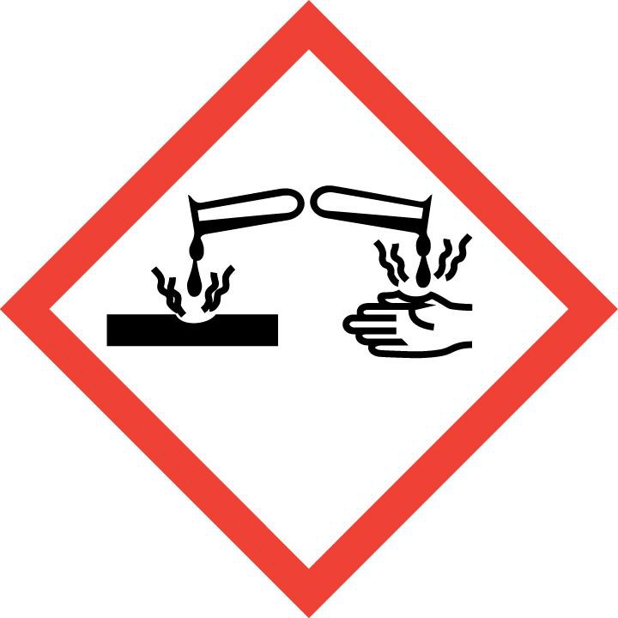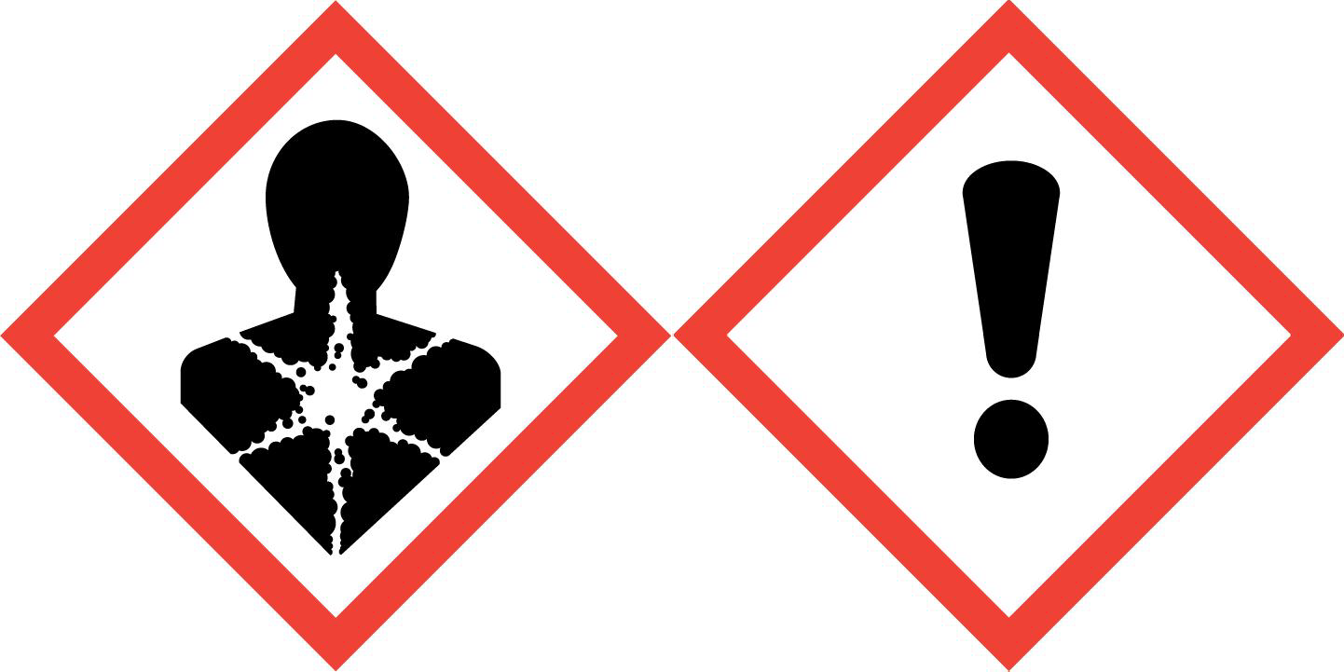

*Signal Word*

DANGER!

*Hazard statement(s)*

Causes serious eye damage.

May cause an allergic skin reaction. Suspected of damaging fertility.

Suspected of causing genetic defects. Suspected of causing cancer.

*Precautionary statement(s)*

Obtain special instructions before use.

Do not handle until all safety precautions have been read and understood. Avoid breathing fumes, mists or vapors.

Contaminated work clothing must not be allowed out of the workplace. Wear protective gloves/clothing and eye/face protection.

IF exposed or concerned: Get medical advice/attention.

IF IN EYES: Rinse cautiously with water for several minutes. Remove contact lenses, if present and easy to do. Continue rinsing. Immediately call a POISON CENTER or doctor/physician.

IF ON SKIN: Wash with plenty of soap and water. Wash contaminated clothing before reuse. If skin irritation or rash occurs: Get medical advice/attention.

Store locked up.

Dispose of contents/container in accordance with local regulation.

### Other hazards

Other hazards which do not result in classification: May cause mild skin irritation. May cause respiratory irritation. Ingestion may cause gastrointestinal irritation, nausea, vomiting and diarrhea.

**SECTION 3. COMPOSITION/INFORMATION ON INGREDIENTS**

Mixture

|  |  |  |  |
| --- | --- | --- | --- |
| **Chemical name** | **Common name and synonyms** | **CAS #** | **Concentration (% by weight)** |
| **Bisphenol A** | 4,4'-Isopropylidenediphenol | 80-05-7 | **80.0 - 100.0** |
| **Butyl 2,3-epoxypropyl ether** | 2,3-Epoxypropyl butyl ether Butoxymethyloxirane  BGE | 2426-08-6 | **1.0 - 5.0** |
| **Crystalline silica, quartz** | Quartz silica Crystallized silicon dioxide | 14808-60-7 | **<0.4** |

The exact concentrations of the above listed chemicals are being withheld as a trade secret.

**SECTION 4. FIRST-AID MEASURES**

### Description of first aid measures

*Ingestion Inhalation*

**:** Do NOT induce vomiting. Have victim rinse mouth with water, then give one to two glasses of water to drink. Never give anything by mouth to an unconscious person. Obtain medical attention if symptoms develop and persist.

**:** Move to fresh air. If breathing is difficult, give oxygen by qualified medical personnel only. If breathing has stopped, give artificial respiration. Obtain medical attention if symptoms develop and persist.

*Skin contact* **:**

*Eye contact* **:**

Wash with plenty of soap and water. If skin irritation or rash occurs: Get medical advice/attention.

Immediately flush eyes with running water for at least 15 minutes. Remove contact lenses, if present and easy to do. Immediately call a POISON CENTER or doctor/physician.

### Most important symptoms and effects, both acute and delayed

**:** Causes serious eye damage. Symptoms may include severe pain, blurred vision, redness and corrosive damage. May cause an allergic skin reaction (e.g. swelling, rash and eczema). May cause mild skin irritation. Symptoms may include redness, itching and swelling. Suspected of damaging fertility. Suspected of causing cancer. Suspected of causing genetic defects.

### Indication of any immediate medical attention and special treatment needed

**:** Treat symptomatically.

**SECTION 5. FIRE-FIGHTING MEASURES**

### Extinguishing media

*Suitable extinguishing media*

### :

Use media suitable to the surrounding fire such as water fog or fine spray, alcohol foams, carbon dioxide and dry chemical.

*Unsuitable extinguishing media*

**:** Do not use a solid water stream as it may scatter and spread fire.

### Special hazards arising from the substance or mixture / Conditions of flammability

**:** Burning may produce irritating, toxic and obnoxious fumes.

### Flammability classification (OSHA 29 CFR 1910.106)

**:** Not flammable.

### Hazardous combustion products

**:** Nitrogen oxides ;Carbon oxides

### Special protective equipment and precautions for firefighters

*Protective equipment for fire-fighters*

**:** Do not enter without wearing specialized protective equipment suitable for the situation. Firefighter's normal protective clothing (Bunker Gear) will not provide adequate protection. A full-body encapsulating chemical protective suit with positive pressure self-contained breathing apparatus (NIOSH approved or equivalent) may be necessary.

*Special fire-fighting procedures*

### :

Firefighters should wear proper protective equipment and self-contained breathing apparatus with full face piece operated in positive pressure mode. Move containers from fire area if safe to do so. Water spray may be useful in cooling equipment exposed to heat and flame.

**SECTION 6. ACCIDENTAL RELEASE MEASURES**

### Personal precautions, protective equipment and emergency procedures

**:**

**Environmental precautions** **:**

Restrict access to area until completion of clean-up. Ensure clean-up is conducted by trained personnel only. Wear suitable protective equipment. Refer to protective measures listed in sections 7 and 8. Restrict access to area until completion of

clean-up.

Ensure spilled product does not enter drains, sewers, waterways, or confined spaces.

### Methods and material for containment and cleaning up

**:** Ventilate area of release. Stop spill or leak at source if safely possible. Dike for water control. Contain and absorb spilled liquid with non-combustible, inert absorbent material (e.g. sand), then place absorbent material into a container for later disposal (see Section 13).

### Special spill response procedures

**:** If a spill/release in excess of the EPA reportable quantity is made into the environment, immediately notify the national response center in the United States (phone: 1-800-424-8802).

US CERCLA Reportable quantity (RQ): See section 15.

**SECTION 7. HANDLING AND STORAGE**

### Precautions for safe handling

**:**

**Conditions for safe storage** **: Incompatible materials** **:**

**SECTION 8. EXPOSURE CONTROLS / PERSONAL PROTECTION**

Use with appropriate and adequate ventilation. Avoid contact with eyes, skin and clothing. Keep away from incompatibles. Keep containers tightly closed when not in use. Wash thoroughly after handling. Avoid breathing mist or vapor. Contaminated work clothing must not be allowed out of the workplace. Do not allow contact with air. Keep containers tightly closed when not in use.

Store in a cool, dry, well-ventilated area. Storage area should be clearly identified, clear of obstruction and accessible only to trained and authorized personnel. Keep container tightly closed. Store at temperatures between 5 to 35°C(41 to 95°F).

Oxidizing agents. ;Amines. ;Alkalies ;Acids

|  |  |  |  |
| --- | --- | --- | --- |
| **Exposure Limits:** |  | | |
| **Chemical Name** | **ACGIH TLV**  **TWA** **STEL** | | **OSHA PEL**  **PEL** **STEL** |
| **Bisphenol A** | **N/Av** | **N/Av** | **N/Av** **N/Av** |
| **Butyl 2,3-epoxypropyl ether** | **3 ppm** | **N/Av** | **50 ppm (270** **N/Av mg/m³)** |
| **Crystalline silica, quartz** | **0.025 mg/m³ (respirable)** | **N/Av** | **0.05 mg/m³** **N/Av**  **(respirable) (final rule limit)** |

**Exposure controls**

### Ventilation and engineering measures

**:** Use in a well-ventilated area. Use general or local exhaust ventilation to maintain air concentrations below recommended exposure limits.

**Respiratory protection** **:** Use the indicated respiratory protection if the occupational exposure limit is exceeded and/or in case of product release (dust and/or fumes). Advice should be sought from respiratory protection specialists.

### Skin protection

**Eye / face protection**

**:** Wear protective gloves. Advice should be sought from glove suppliers.

**:** Wear eye/face protection. Wear safety glasses with side shields ( or goggles).

**Other protective equipment :** Wear sufficient clothing to prevent skin contact. Depending on conditions of use, an impervious apron should be worn. An eyewash station and safety shower should be made available in the immediate working area.

### General hygiene considerations

**:** Avoid contact with skin, eyes and clothing. Upon completion of work, wash hands before eating, drinking, smoking or use of toilet facilities. Handle in accordance with good industrial hygiene and safety practice. Contaminated work clothing must not be allowed out of the workplace.

**SECTION 9. PHYSICAL AND CHEMICAL PROPERTIES**

### Appearance Odour

**:** Red thixatropic semisolid.

**:** Not available.

**Odour threshold** **:** Not available.

**pH** **:**

### Melting Point/Freezing point :

Not available.

Not available.

### Initial boiling point and boiling range

**:** Not available

**Flash point** **:** Not available.

**Flashpoint (Method)** **:** Not available.

**Evaporation rate (BuAe = 1) :** Not available.

**Flammability (solid, gas)** **:** Not applicable.

### Lower flammable limit (% by vol.)

**:** Not applicable.

### Upper flammable limit (% by vol.)

**Oxidizing properties**

**:** Not applicable.

**:** Not applicable

**Explosive properties** **:** Not explosive

### Vapour pressure Vapour density

**:** Not available.

**:** Not available.

### Relative density / Specific gravity

**:** Not available.

**Solubility in water** **:** Not determined.

**Other solubility(ies)** **:** Not available.

### Partition coefficient: n-octanol/water or Coefficient of water/oil distribution

**Auto-ignition temperature**

**:** Not available.

**:** Not applicable.

**Decomposition temperature :** Not available.

### Viscosity :

**Volatiles (% by weight)** **:**

Not available.

Not available.

### Volatile organic Compounds (VOC's)

**:**

**Absolute pressure of container**

Not available.

**:** Not applicable. **Flame projection length** **:** Not applicable. **Other physical/chemical comments**

**:** None known or reported by the manufacturer.

**SECTION 10. STABILITY AND REACTIVITY**

### Reactivity

**Chemical stability**

**:** This product is not reactive.

**:** Material is stable under normal conditions.

### Possibility of hazardous reactions

**:** Under normal conditions of handling and storage, hazardous reactions will not occur.

**Conditions to avoid** **:** Excessive heat. ;Exposure to air.

**Incompatible materials** **:** See Section 7 (Handling and Storage) for further details.

### Hazardous decomposition products

**:** None known, refer to hazardous combustion products in Section 5.

**SECTION 11. TOXICOLOGICAL INFORMATION**

**Information on likely routes of exposure:**

### Routes of entry inhalation Routes of entry skin & eye Routes of entry Ingestion

**:** YES

**:** YES

**:** YES

### Routes of exposure skin absorption

**:** NO

**Potential Health Effects:**

### Signs and symptoms of short-term (acute) exposure

*Sign and symptoms Inhalation*

### :

*Sign and symptoms ingestion*

May cause respiratory irritation. Symptoms may include sore throat, running nose and shortness of breath.

*Sign and symptoms skin Sign and symptoms eyes*

**:** Ingestion may cause gastrointestinal irritation, nausea, vomiting and diarrhea.

**:** Causes skin irritation. Symptoms may include redness, blistering, pain and swelling.

**:** Causes severe eye irritation. Symptoms may include redness, pain, tearing and conjunctivitis.

### Potential Chronic Health Effects

**:**

Frequent or prolonged contact may dry the skin, leading to discomfort and dermatitis.

**Mutagenicity** **:** Not expected to be mutagenic in humans.

**Carcinogenicity** **:** No components are listed as carcinogens by ACGIH, IARC, OSHA or NTP.

### Reproductive effects & Teratogenicity

**:** This material is classified as hazardous under U.S. OSHA regulations (29CFR 1910.1200) (Hazcom 2012) and Canadian WHMIS regulations (Hazardous Products Regulations) (WHMIS 2015). Classification: Reproductive toxicity - Category 2 Suspected of damaging the unborn child.

**Sensitization to material** **:** May cause an allergic skin reaction (e.g. swelling, rash and eczema). Not expected to be a respiratory sensitizer.

**Specific target organ effects :** This material is not classified as hazardous under U.S. OSHA regulations (29CFR 1910.1200) (Hazcom 2012) and Canadian WHMIS regulations (Hazardous Products Regulations) (WHMIS 2015).

### Medical conditions aggravated by overexposure

**:** None known.

**Synergistic materials** **:** Not available.

### Toxicological data :

There is no available data for the product itself, only for the ingredients. See below for individual ingredient acute toxicity data.

|  |  |  |  |
| --- | --- | --- | --- |
| **Chemical name** | **LC50(4hr)**  **inh, rat** | **LD50** | |
| **(Oral, rat)** | **(Rabbit, dermal)** |
| Bisphenol A | N/Av | N/Av | N/Av |
| Butyl 2,3-epoxypropyl ether | 2590 ppm (13.77 mg/L) (vapour) | 1660 mg/kg | > 2150 mg/kg |
| Crystalline silica, quartz | N/Av | N/Av | N/Av |

### Other important toxicological hazards

**:** None known or reported by the manufacturer.

.

**SECTION 12. ECOLOGICAL INFORMATION**

### Ecotoxicity

**:** Toxic to aquatic life with long lasting effects. Do not allow this material to drain into sewers/water supplies.

***Ecotoxicity data:***

|  |  |  |  |  |
| --- | --- | --- | --- | --- |
| **Ingredients** | **CAS #** | **Toxicity to Fish** | | |
| **LC50 / 96h** | **NOEC / 21 day** | **M Factor** |
| Bisphenol A | 80-05-7 | N/Av | N/Av | None. |
| Butyl 2,3-epoxypropyl ether | 2426-08-6 | 65 mg/L (Rainbow trout) | N/Av | None. |
| Crystalline silica, quartz | 14808-60-7 | N/Av | N/Av | None. |

|  |  |  |  |  |
| --- | --- | --- | --- | --- |
| **Ingredients** | **CAS #** | **Toxicity to Daphnia** | | |
| **EC50 / 48h** | **NOEC / 21 day** | **M Factor** |
| Bisphenol A | 80-05-7 | N/Av | N/Av | None. |
| Butyl 2,3-epoxypropyl ether | 2426-08-6 | 3.9 mg/L (Daphnia magna) | N/Av | None. |
| Crystalline silica, quartz | 14808-60-7 | N/Av | N/Av | None. |

|  |  |  |  |  |
| --- | --- | --- | --- | --- |
| **Ingredients** | **CAS #** | **Toxicity to Algae** | | |
| **EC50 / 96h or 72h** | **NOEC / 96h or 72h** | **M Factor** |
| Bisphenol A | 80-05-7 | N/Av | N/Av | None. |
| Butyl 2,3-epoxypropyl ether | 2426-08-6 | 35 mg/L/96hr (Green algae) | N/Av | None. |
| Crystalline silica, quartz | 14808-60-7 | N/Av | N/Av | None. |

### Persistence and degradability

**:**

No data is available on the product itself.

**Bioaccumulation potential** **:** No data is available on the product itself.

|  |  |  |
| --- | --- | --- |
| **Components** | **Partition coefficient n-octanol/water (log Kow)** | **Bioconcentration factor (BCF)** |
| Bisphenol A (CAS 80-05-7) |  | 5.1 - 13.8 BCF method: OEC |
| Butyl 2,3-epoxypropyl ether (CAS 2426-08-6) | 0.63 |  |

**Mobility in soil** **:** No data is available on the product itself.

### Other Adverse Environmental effects

**:** No other adverse environmental effects (e.g. ozone depletion, photochemical ozone creation potential, endocrine disruption, global warming potential) are expected from this component.

**SECTION 13. DISPOSAL CONSIDERATIONS**

### Handling for Disposal

**Methods of Disposal**

**:** Collect and reclaim or dispose in sealed containers at licensed waste disposal site. Dispose of contents/container in accordance with local/regional/national/international regulations.

**:** Dispose in accordance with all applicable federal, state, provincial and local regulations.

### RCRA

**:** If this product, as supplied, becomes a waste in the United States, it may meet the criteria of a hazardous waste as defined under RCRA, Title 40 CFR 261. It is the responsibility of the waste generator to determine the proper waste identification and disposal method. For disposal of unused or waste material, check with local, state and federal environmental agencies.

**SECTION 14. TRANSPORT INFORMATION**

|  |  |  |  |  |  |
| --- | --- | --- | --- | --- | --- |
| **Regulatory Information** | **UN Number** | **UN proper shipping name** | **Transport hazard class(es)** | **Packing Group** | **Label** |
| TDG  **TDG**  **Additional information** | UN3077 | ENVIRONMENTALLY HAZARDOUS SUBSTANCE,  SOLID, N.O.S. (4,4'-Isopropylidenediphenol) | 9 | III |  |
|  |  |  |  |  |
| IMDG  **IMDG**  **Additional information** | UN3077 | ENVIRONMENTALLY HAZARDOUS SUBSTANCE,  SOLID, N.O.S. (4,4'-Isopropylidenediphenol) | 9 | III |  |
| May be shipped as Limited Quantity when transported in containers no larger than 5.0 kg; in packages not exceeding 30 kg gross mass. | | | | |
| ICAO/IATA  **ICAO/IATA**  **Additional information** | UN3077 | Environmentally hazardous substance, solid, n.o.s. (4,4'-Isopropylidenediphenol) | 9 | III |  |
| Refer to the appropriate Packing Instruction, prior to shipping this material. Review all State and Operator Variations, prior to shipping this material. | | | | |
| 49CFR/DOT  **49CFR/DOT**  **Additional information** | None. | Not regulated. | not regulated | none |  |
| None. | | | | |

### Special precautions for user

**:** None known or reported by the manufacturer.

**Environmental hazards** **:** This substance meets the criteria for an environmentally hazardous substance

according to the IMDG Code. See ECOLOGICAL INFORMATION, Section 12.

.

### Transport in bulk according to Annex II of MARPOL 73/78 and the IBC Code

**:** Not available.

**SECTION 15 - REGULATORY INFORMATION**

**US Federal Information:**

Components listed below are present on the following U.S. Federal chemical lists:

|  |  |  |  |  |  |  |
| --- | --- | --- | --- | --- | --- | --- |
| **Ingredients** | **CAS #** | **TSCA**  **Inventory** | **CERCLA**  **Reportable Quantity(RQ) (40**  **CFR 117.302):** | **SARA TITLE III: Sec. 302,**  **Extremely Hazardous Substance, 40**  **CFR 355:** | **SARA TITLE III: Sec. 313, 40 CFR**  **372, Specific Toxic Chemical** | |
| **Toxic Chemical** | **de minimus Concentration** |
| Bisphenol A | 80-05-7 | Yes | N/Ap | N/Av | Yes | N/Ap |
| Butyl 2,3-epoxypropyl  ether | 2426-08-6 | Yes | None. | None. | No | N/Ap |
| Crystalline silica, quartz | 14808-60-7 | Yes | None. | None. | No | N/Ap |

SARA TITLE III: Sec. 311 and 312, SDS Requirements, 40 CFR 370 Hazard Classes: Skin sensitization; Eye Damage.;Reproductive toxicity ;Germ cell mutagenicity; Carcinogenicity.

Under SARA Sections 311 and 312, the EPA has established threshold quantities for the reporting of hazardous chemicals. The current thresholds are 500 pounds or the threshold planning quantity (TPQ), whichever is lower, for extremely hazardous substances and 10,000 pounds for all other hazardous chemicals.

**US State Right to Know Laws:**

The following chemicals are specifically listed by individual States:

|  |  |  |  |  |  |  |  |  |  |
| --- | --- | --- | --- | --- | --- | --- | --- | --- | --- |
| **Ingredients** | **CAS #** | **California Proposition 65** | | **State "Right to Know" Lists** | | | | | |
| **Listed** | **Type of Toxicity** | **CA** | **MA** | **MN** | **NJ** | **PA** | **RI** |
| Bisphenol A | 80-05-7 | No | female reproductive toxicity | Yes | Yes | No | Yes | Yes | No |
| Butyl 2,3-epoxypropyl ether | 2426-08-6 | No | N/Ap | Yes | Yes | Yes | Yes | Yes | Yes |
| Crystalline silica, quartz | 14808-60-7 | Yes | Cancer (airborne particles of respirable size) | No | Yes | Yes | Yes | Yes | Yes |

**Canadian Information:**

WHMIS information: Refer to Section 2 for a WHMIS Classification for this product.

Canadian Environmental Protection Act (CEPA) information: All ingredients listed appear on the Domestic Substances List (DSL).

**International Information:**

Components listed below are present on the following International Inventory list:

|  |  |  |  |  |  |  |  |  |
| --- | --- | --- | --- | --- | --- | --- | --- | --- |
| **Ingredients** | **CAS #** | **European EINECs** | **Australia AICS** | **Philippines PICCS** | **Japan ENCS** | **Korea KECI/KECL** | **China IECSC** | **NewZealand IOC** |
| Bisphenol A | 80-05-7 | 201-245-8 | N/Av | N/Av | N/Av | N/Av | N/Av | N/Av |
| Butyl 2,3-epoxypropyl  ether | 2426-08-6 | 219-376-4 | Present | Present | (2)-392 | KE-04158 | Present | HSR002921 |
| Crystalline silica, quartz | 14808-60-7 | 238-878-4 | Present | Present | (1)-548 | KE-29983 | Present | HSR003125 |

**SECTION 16. OTHER INFORMATION**

### Legend

**:** ACGIH: American Conference of Governmental Industrial Hygienists CAS: Chemical Abstract Services

CERCLA: Comprehensive Environmental Response, Compensation, and Liability Act

### References :

of 1980

CFR: Code of Federal Regulations CSA: Canadian Standards Association DOT: Department of Transportation EPA: Environmental Protection Agency

HMIS: Hazardous Materials Identification System HSDB: Hazardous Substances Data Bank

IARC: International Agency for Research on Cancer Inh: Inhalation

LC: Lethal Concentration LD: Lethal Dose

MN: Minnesota N/Ap: Not Applicable N/Av: Not Available

NFPA: National Fire Protection Association

NIOSH: National Institute of Occupational Safety and Health NJ: New Jersey

NTP: National Toxicology Program

OECD: Organisation for Economic Co-operation and Development OSHA: Occupational Safety and Health Administration

PA: Pennsylvania

PEL: Permissible exposure limit

RCRA: Resource Conservation and Recovery Act RI: Rhode Island

RTECS: Registry of Toxic Effects of Chemical Substances SARA: Superfund Amendments and Reauthorization Act STEL: Short Term Exposure Limit

TLV: Threshold Limit Values TWA: Time Weighted Average

WHMIS: Workplace Hazardous Materials Identification System

1. ACGIH, Threshold Limit Values for Chemical Substances and Physical Agents & Biological Exposure Indices
2. ECHA - European Chemical Agency
3. Canadian Centre for Occupational Health and Safety, CCInfoWeb databases, (Chempendium, HSDB and RTECs).
4. Safety Data Sheets from manufacturer.
5. US EPA Title III List of Lists
6. California Proposition 65 List
7. OECD - The Global Portal to Information on Chemical Substances - eChemPortal

### Preparation Date (mm/dd/yyyy)

**:** 07/09/2021

### Other special considerations for handling

**:** Provide adequate information, instruction and training for operators.

|  |  |
| --- | --- |
| **Prepared for:**  Beacon Adhesives  125 Macquesten Parkway South Mount Vernon, NY 10550 Telephone: (914) 699 3400 |  |
| [**Prepared by:**](http://www.thecompliancecenter.com/)  [ICC The Compliance Center Inc.](http://www.thecompliancecenter.com/)  [Telephone: (888) 442-9628 (U.S.): (888) 977-4834 (Canada)](http://www.thecompliancecenter.com/)  [http://www.thecompliancecenter.com](http://www.thecompliancecenter.com/) |  |

# DISCLAIMER

This Safety Data Sheet was prepared by ICC The Compliance Center Inc. using information provided by Beacon Adhesives and CCOHS’ Web Information Service. The information in the Safety Data Sheet is offered for your consideration and guidance when exposed to this product. ICC The Compliance Center Inc and Beacon Adhesives expressly disclaim all expressed or implied warranties and assume no responsibilities for the accuracy or completeness of the data contained herein. The data in this SDS does not apply to use with any other product or in any other process.

This Safety Data Sheet may not be changed, or altered in any way without the expressed knowledge and permission of ICC The Compliance Center Inc. and Beacon Adhesives.

## END OF DOCUMENT